

**Orient OS-13 MP14 BM Pattern Series 1 Ton**

**Rs. 38,500/-**

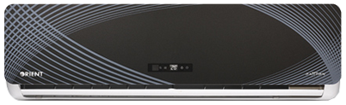

**Product Features**

* more luxury to your living room
* anti dust
* 24 hours timer
* Independent Dehumidification
* Low Noise Air Flow System

**Specification**

**Type** Wall Mounted Split AC

**Cooling (Btu/h)** 47000

**Voltage (V)** 220-240

**Power Input (W)** 3800

**EER (Btu/W-h-W/W)** 7.2-2.8